WORKING WITH IAM USER

Step 1: Create a Free Account & Login as Root user.

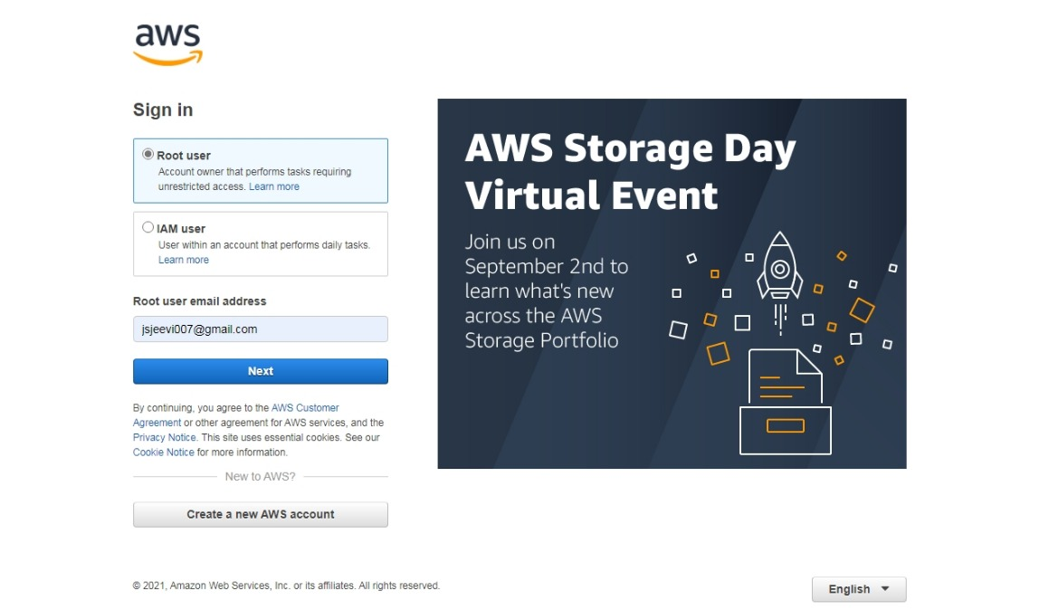

Step 2: Leads to AWS Management Console Page

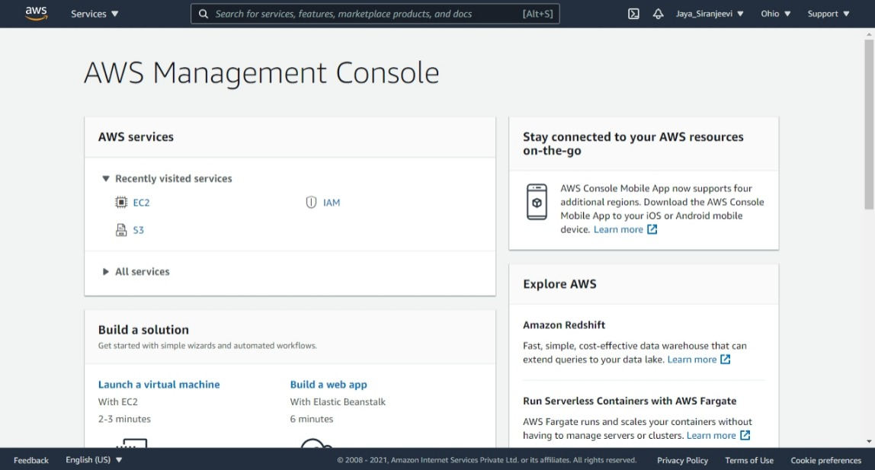

Step 3: IAM dashboard

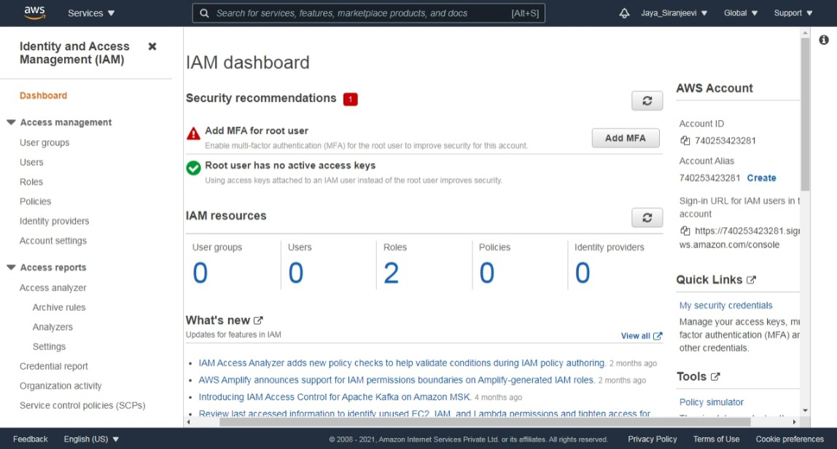

Step 4a: Add User to IAM

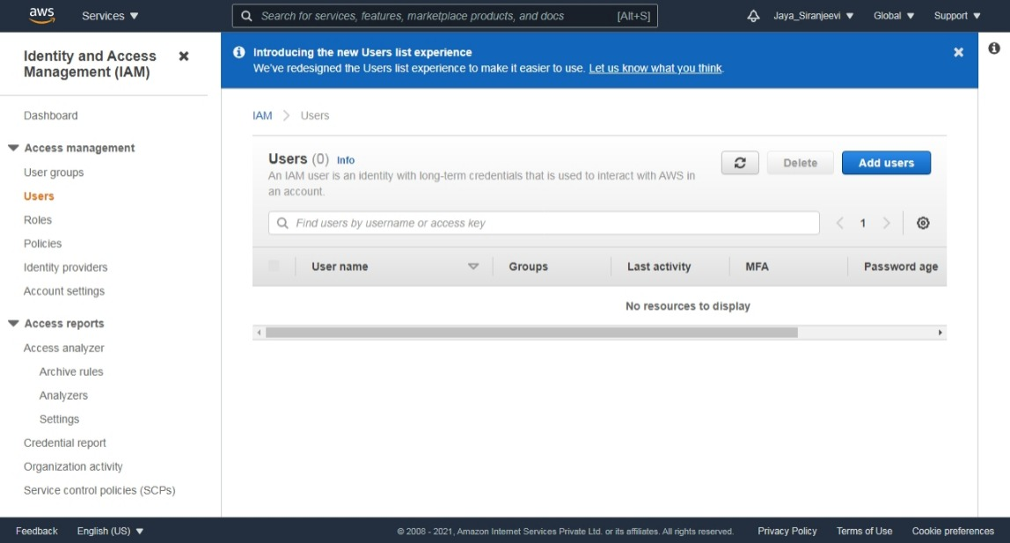

Step 4b: Set User Detail

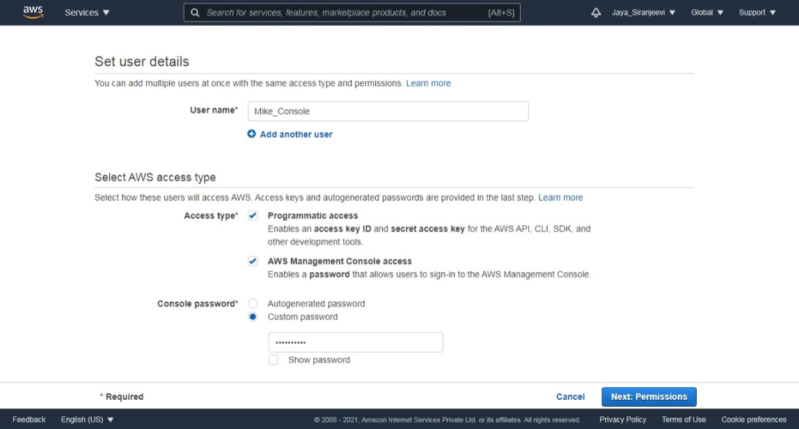

Step 4c:

Set permission to the IAM User. Here permission selected is AmazonS3FullAccess & AmazonEC2ContainerRegistryFullAccess

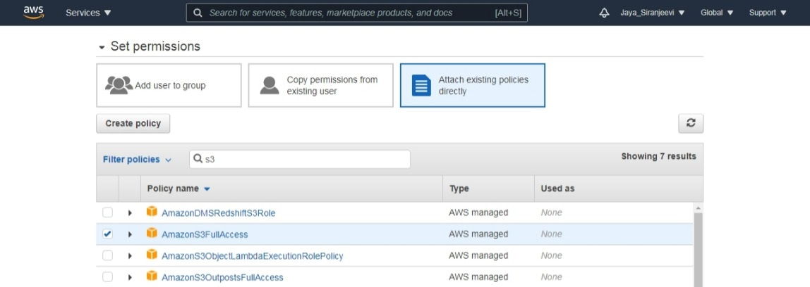

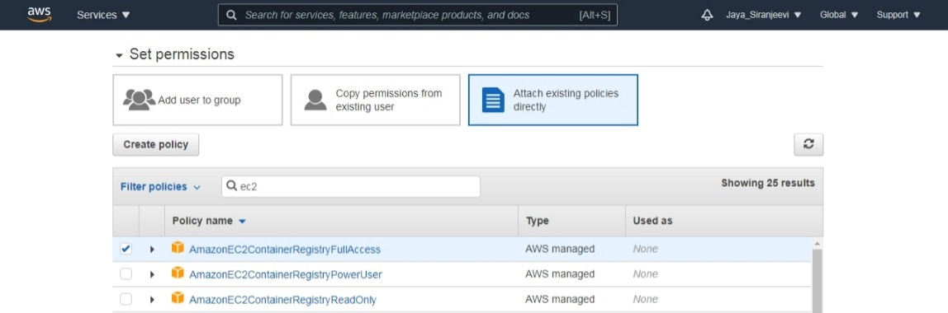

Step 4d: Add tags

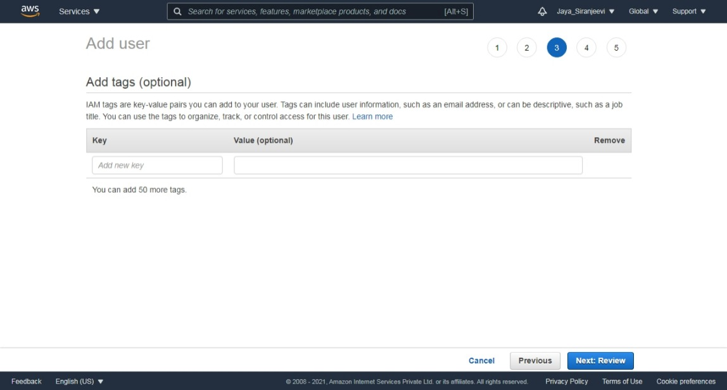

Step 4e: Review of the IAM user detail & User added.

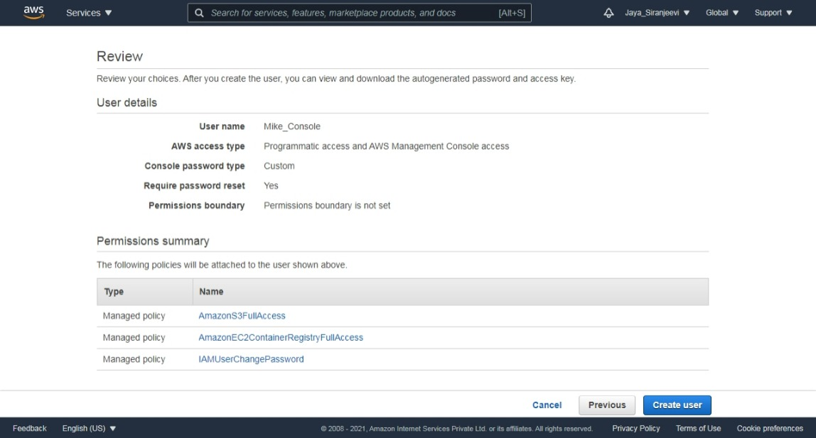

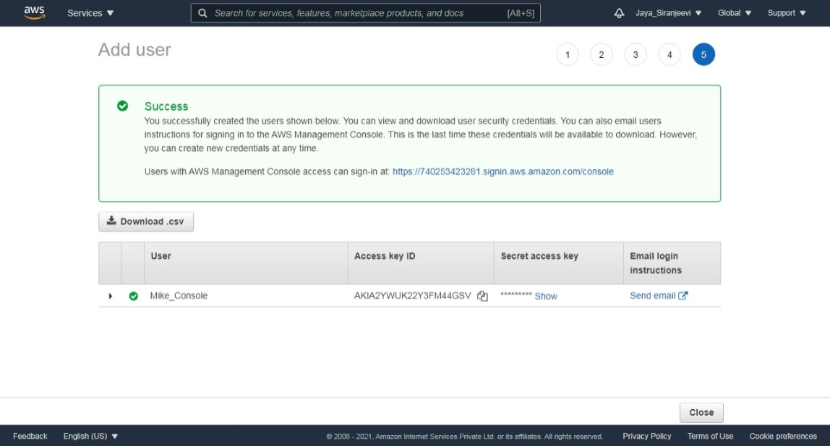

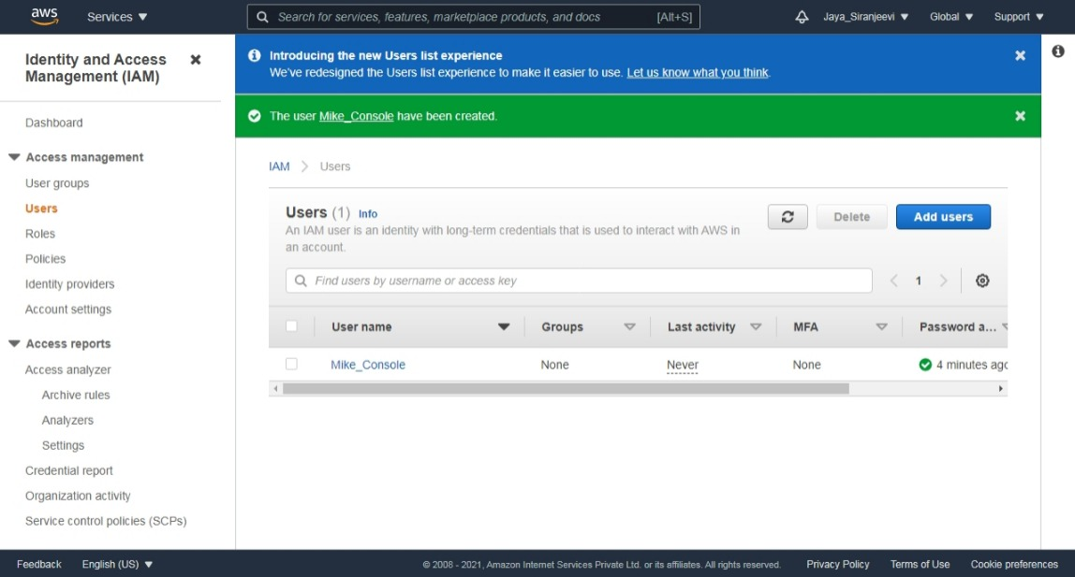

Step 5: Sign In to IAM user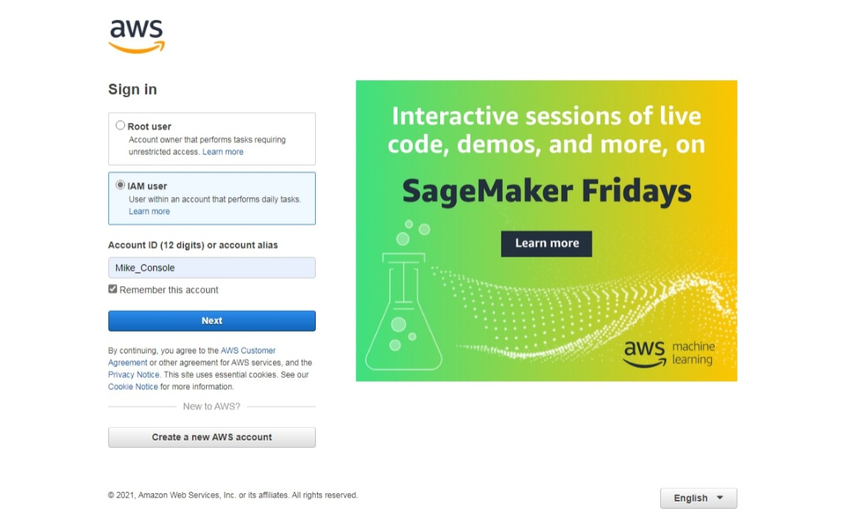

Password Reset on Login as IAM User

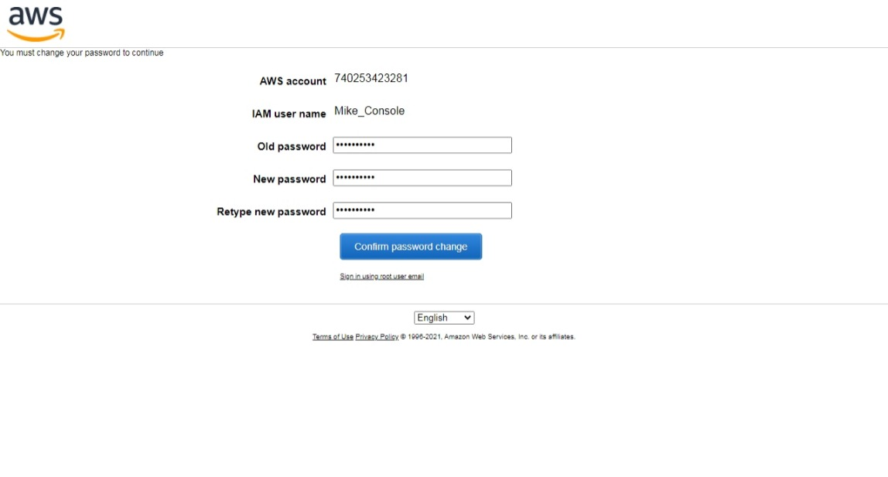

Step 6: Accessing EC2, S3 & other AWS services. 

Amazon S3 Service

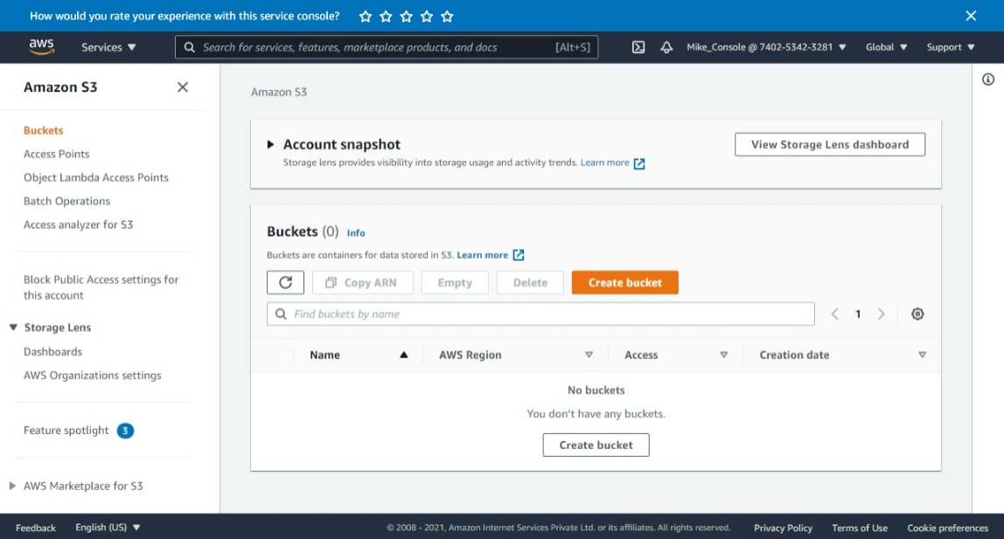

Can create bucket on S3 Service

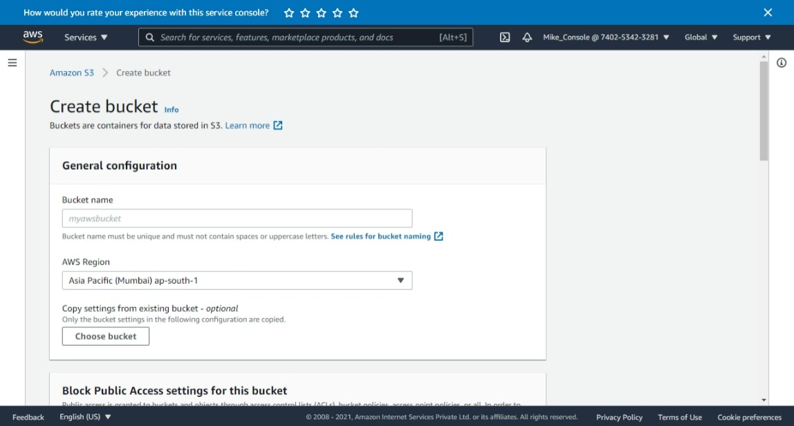

EC2 Experience Services

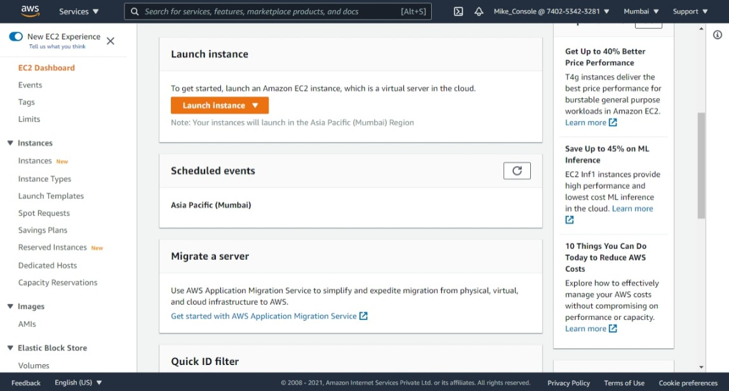

But IAM User cannot use IAM dashboard because this user doesn’t have access other than EC2 & S3 service.

